Kubernetes VM – [For Signoz]
INSTALL OPENTELEMETRY OPERATOR
STEP-1: Install cert-manager
kubectl apply -f https://github.com/cert-manager/cert-manager/releases/download/v1.13.0/cert-manager.yaml
STEP-2: Wait for cert-manager to be ready
kubectl wait --for=condition=available --timeout=300s deployment/cert-manager -n cert-manager
kubectl wait --for=condition=available --timeout=300s deployment/cert-manager-webhook -n cert-manager
kubectl wait --for=condition=available --timeout=300s deployment/cert-manager-cainjector -n cert-manager
STEP-3: Apply the OpenTelemetry Operator
kubectl apply -f https://github.com/open-telemetry/opentelemetry-operator/releases/latest/download/opentelemetry-operator.yaml
STEP-4: Verify the Operator Installation
kubectl get deployment opentelemetry-operator-controller-manager -n opentelemetry-operator-system
Check the pods:
kubectl get pods -n opentelemetry-operator-system

CONFIGURE OPENTELEMETRY OPERATOR
STEP-1: Create Configuration files
Important: Replace <SIGNOZ_OTLP_GRPC_ENDPOINT> with your SigNoz OTel collector endpoint (format: http://<signoz-otel-collector-ip>:4317).
- DaemonSet RBAC (rbac-daemonset.yaml)
cat > rbac-daemonset.yaml <<'EOF'
apiVersion: rbac.authorization.k8s.io/v1
kind: ClusterRole
metadata:
name: signoz-collector-daemonset-collector-role
rules:
- apiGroups: ['']
resources: [pods, namespaces, nodes, persistentvolumeclaims]
verbs: [get, list, watch]
- apiGroups: ['apps']
resources: [replicasets]
verbs: [get, list, watch]
- apiGroups: ['extensions']
resources: [replicasets]
verbs: [get, list, watch]
- apiGroups: ['']
resources: [nodes, endpoints]
verbs: [list, watch]
- apiGroups: ['batch']
resources: [jobs]
verbs: [list, watch]
- apiGroups: ['']
resources: [nodes/proxy]
verbs: [get]
- apiGroups: ['']
resources: [nodes/stats, configmaps, events]
verbs: [create, get]
- apiGroups: ['']
resourceNames: [otel-container-insight-clusterleader]
resources: [configmaps]
verbs: [get, update]
---
apiVersion: rbac.authorization.k8s.io/v1
kind: ClusterRoleBinding
metadata:
name: signoz-collector-daemonset-collector-binding
roleRef:
apiGroup: rbac.authorization.k8s.io
kind: ClusterRole
name: signoz-collector-daemonset-collector-role
subjects:
- kind: ServiceAccount
name: signoz-collector-daemonset-collector
namespace: opentelemetry-operator-system
EOF

- DaemonSet Collector (collector-daemonset.yaml)
cat > collector-daemonset.yaml <<'EOF'
apiVersion: opentelemetry.io/v1beta1
kind: OpenTelemetryCollector
metadata:
name: signoz-collector-daemonset
namespace: opentelemetry-operator-system
spec:
mode: daemonset
image: docker.io/otel/opentelemetry-collector-contrib:0.139.0
env:
- name: OTEL_EXPORTER_OTLP_ENDPOINT
value: '<SIGNOZ_OTLP_GRPC_ENDPOINT>' # e.g., http://192.168.1.100:4317
- name: K8S_CLUSTER_NAME
value: 'my-k3s-cluster' # Change this to your cluster name
- name: K8S_NODE_NAME
valueFrom:
fieldRef:
fieldPath: spec.nodeName
- name: K8S_POD_IP
valueFrom:
fieldRef:
apiVersion: v1
fieldPath: status.podIP
- name: K8S_HOST_IP
valueFrom:
fieldRef:
fieldPath: status.hostIP
- name: K8S_POD_NAME
valueFrom:
fieldRef:
fieldPath: metadata.name
- name: K8S_POD_UID
valueFrom:
fieldRef:
fieldPath: metadata.uid
- name: K8S_NAMESPACE
valueFrom:
fieldRef:
fieldPath: metadata.namespace
- name: SIGNOZ_COMPONENT
value: otel-daemonset
- name: OTEL_RESOURCE_ATTRIBUTES
value: signoz.component=$(SIGNOZ_COMPONENT),k8s.cluster.name=$(K8S_CLUSTER_NAME)
- name: OTEL_EXPORTER_OTLP_INSECURE
value: 'true'
volumes:
- name: varlog
hostPath:
path: /var/log
- name: varlibdockercontainers
hostPath:
path: /var/lib/docker/containers
- name: hostfs
hostPath:
path: /
volumeMounts:
- name: varlog
mountPath: /var/log
readOnly: true
- name: varlibdockercontainers
mountPath: /var/lib/docker/containers
readOnly: true
- name: hostfs
mountPath: /hostfs
readOnly: true
mountPropagation: HostToContainer
config:
exporters:
otlp:
endpoint: ${env:OTEL_EXPORTER_OTLP_ENDPOINT}
tls:
insecure: true
extensions:
health_check:
endpoint: 0.0.0.0:13133
pprof:
endpoint: localhost:1777
zpages:
endpoint: localhost:55679
processors:
batch:
send_batch_size: 10000
timeout: 200ms
k8sattributes:
extract:
metadata:
- k8s.namespace.name
- k8s.deployment.name
- k8s.statefulset.name
- k8s.daemonset.name
- k8s.cronjob.name
- k8s.job.name
- k8s.node.name
- k8s.node.uid
- k8s.pod.name
- k8s.pod.uid
- k8s.pod.start_time
filter:
node_from_env_var: K8S_NODE_NAME
passthrough: false
pod_association:
- sources:
- from: resource_attribute
name: k8s.pod.ip
- sources:
- from: resource_attribute
name: k8s.pod.uid
- sources:
- from: connection
resourcedetection:
detectors:
- k8snode
- env
- system
k8snode:
auth_type: serviceAccount
node_from_env_var: K8S_NODE_NAME
override: false
system:
resource_attributes:
host.id:
enabled: false
host.name:
enabled: false
os.type:
enabled: true
timeout: 2s
receivers:
filelog/k8s:
exclude:
- /var/log/pods/opentelemetry-operator-system_*/*/*.log
- /var/log/pods/kube-system_*/*/*.log
include:
- /var/log/pods/*/*/*.log
include_file_name: false
include_file_path: true
operators:
- id: container-parser
type: container
start_at: end
hostmetrics:
collection_interval: 30s
root_path: /hostfs
scrapers:
cpu: {}
disk: {}
filesystem:
exclude_fs_types:
fs_types:
- autofs
- binfmt_misc
- bpf
- cgroup2?
- configfs
- debugfs
- devpts
- devtmpfs
- fusectl
- hugetlbfs
- iso9660
- mqueue
- nsfs
- overlay
- proc
- procfs
- pstore
- rpc_pipefs
- securityfs
- selinuxfs
- squashfs
- sysfs
- tracefs
match_type: strict
load: {}
memory: {}
network: {}
kubeletstats:
auth_type: serviceAccount
collection_interval: 30s
endpoint: ${env:K8S_HOST_IP}:10250
extra_metadata_labels:
- container.id
- k8s.volume.type
insecure_skip_verify: true
metric_groups:
- container
- pod
- node
- volume
otlp:
protocols:
grpc:
endpoint: 0.0.0.0:4317
http:
endpoint: 0.0.0.0:4318
service:
extensions:
- health_check
- zpages
- pprof
pipelines:
logs:
exporters:
- otlp
processors:
- resourcedetection
- k8sattributes
- batch
receivers:
- otlp
- filelog/k8s
metrics:
exporters:
- otlp
processors:
- resourcedetection
- k8sattributes
- batch
receivers:
- otlp
- hostmetrics
- kubeletstats
traces:
exporters:
- otlp
processors:
- resourcedetection
- k8sattributes
- batch
receivers:
- otlp
telemetry:
logs:
encoding: json
EOF

- Deployment RBAC (rbac-deployment.yaml)
cat > rbac-deployment.yaml <<'EOF'
apiVersion: rbac.authorization.k8s.io/v1
kind: ClusterRole
metadata:
name: signoz-collector-deployment-collector-role
rules:
- apiGroups: ['']
resources:
- events
- namespaces
- namespaces/status
- nodes
- nodes/spec
- pods
- pods/status
- replicationcontrollers
- replicationcontrollers/status
- resourcequotas
- services
verbs: [get, list, watch]
- apiGroups: ['apps']
resources: [daemonsets, deployments, replicasets, statefulsets]
verbs: [get, list, watch]
- apiGroups: ['extensions']
resources: [daemonsets, deployments, replicasets]
verbs: [get, list, watch]
- apiGroups: ['batch']
resources: [jobs, cronjobs]
verbs: [get, list, watch]
- apiGroups: ['autoscaling']
resources: [horizontalpodautoscalers]
verbs: [get, list, watch]
---
apiVersion: rbac.authorization.k8s.io/v1
kind: ClusterRoleBinding
metadata:
name: signoz-collector-deployment-collector-binding
roleRef:
apiGroup: rbac.authorization.k8s.io
kind: ClusterRole
name: signoz-collector-deployment-collector-role
subjects:
- kind: ServiceAccount
name: signoz-collector-deployment-collector
namespace: opentelemetry-operator-system
EOF

- Deployment Collector (collector-deployment.yaml)
cat > collector-deployment.yaml <<'EOF'
apiVersion: opentelemetry.io/v1beta1
kind: OpenTelemetryCollector
metadata:
name: signoz-collector-deployment
namespace: opentelemetry-operator-system
spec:
mode: deployment
image: docker.io/otel/opentelemetry-collector-contrib:0.139.0
env:
- name: OTEL_EXPORTER_OTLP_ENDPOINT
value: '<SIGNOZ_OTLP_GRPC_ENDPOINT>' # e.g., http://192.168.1.100:4317
- name: K8S_CLUSTER_NAME
value: 'my-k3s-cluster' # Change this to your cluster name
- name: K8S_NODE_NAME
valueFrom:
fieldRef:
fieldPath: spec.nodeName
- name: K8S_POD_IP
valueFrom:
fieldRef:
apiVersion: v1
fieldPath: status.podIP
- name: K8S_HOST_IP
valueFrom:
fieldRef:
fieldPath: status.hostIP
- name: K8S_POD_NAME
valueFrom:
fieldRef:
fieldPath: metadata.name
- name: K8S_POD_UID
valueFrom:
fieldRef:
fieldPath: metadata.uid
- name: K8S_NAMESPACE
valueFrom:
fieldRef:
fieldPath: metadata.namespace
- name: SIGNOZ_COMPONENT
value: otel-deployment
- name: OTEL_RESOURCE_ATTRIBUTES
value: signoz.component=$(SIGNOZ_COMPONENT),k8s.cluster.name=$(K8S_CLUSTER_NAME)
config:
exporters:
otlp:
endpoint: ${env:OTEL_EXPORTER_OTLP_ENDPOINT}
tls:
insecure: true
extensions:
health_check:
endpoint: 0.0.0.0:13133
pprof:
endpoint: localhost:1777
zpages:
endpoint: localhost:55679
processors:
batch:
send_batch_size: 10000
timeout: 1s
k8sattributes:
extract:
metadata:
- k8s.namespace.name
- k8s.deployment.name
- k8s.statefulset.name
- k8s.daemonset.name
- k8s.cronjob.name
- k8s.job.name
- k8s.node.name
- k8s.node.uid
- k8s.pod.name
- k8s.pod.uid
- k8s.pod.start_time
passthrough: false
pod_association:
- sources:
- from: resource_attribute
name: k8s.pod.ip
- sources:
- from: resource_attribute
name: k8s.pod.uid
- sources:
- from: connection
resourcedetection:
detectors:
- env
override: false
timeout: 2s
receivers:
k8s_cluster:
allocatable_types_to_report:
- cpu
- memory
collection_interval: 30s
metrics:
k8s.node.condition:
enabled: true
k8s.pod.status_reason:
enabled: true
node_conditions_to_report:
- Ready
- MemoryPressure
- DiskPressure
- PIDPressure
resource_attributes:
container.runtime:
enabled: true
container.runtime.version:
enabled: true
k8s.kubelet.version:
enabled: true
k8s.pod.qos_class:
enabled: true
k8s_events:
auth_type: serviceAccount
service:
extensions:
- health_check
- zpages
- pprof
pipelines:
logs:
exporters:
- otlp
processors:
- k8sattributes
- resourcedetection
- batch
receivers:
- k8s_events
metrics/internal:
exporters:
- otlp
processors:
- k8sattributes
- resourcedetection
- batch
receivers:
- k8s_cluster
telemetry:
logs:
encoding: json
EOF
VERIFY AND RESULT
Check Collector logs
# Check DaemonSet logs
kubectl logs -n opentelemetry-operator-system daemonset/signoz-collector-daemonset-collector --tail=100

# Check Deployment logs
kubectl logs -n opentelemetry-operator-system deployment/signoz-collector-deployment-collector --tail=100
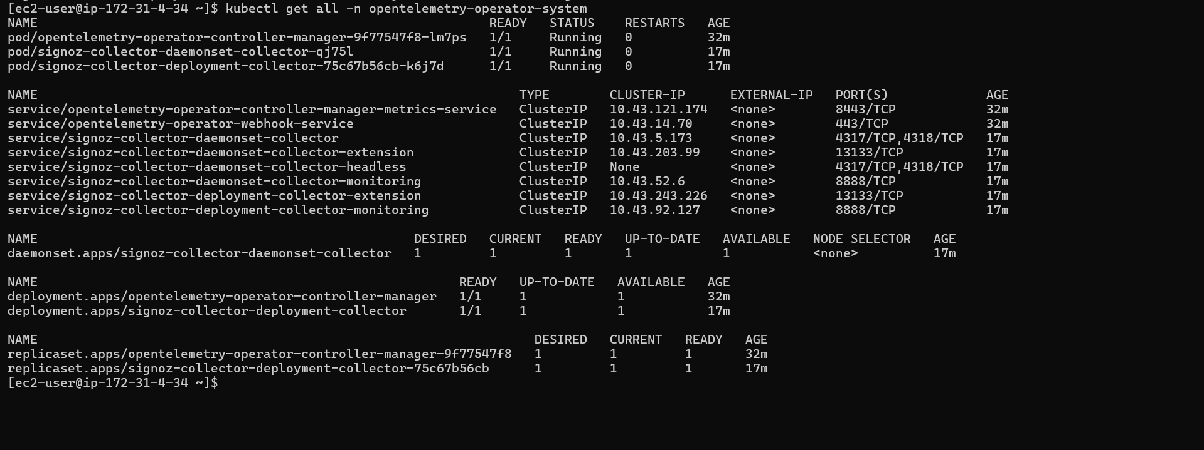

Check Signoz UI
http://<Signoz VM IP>:8080/
http://13.61.5.212:8080/

Metrics
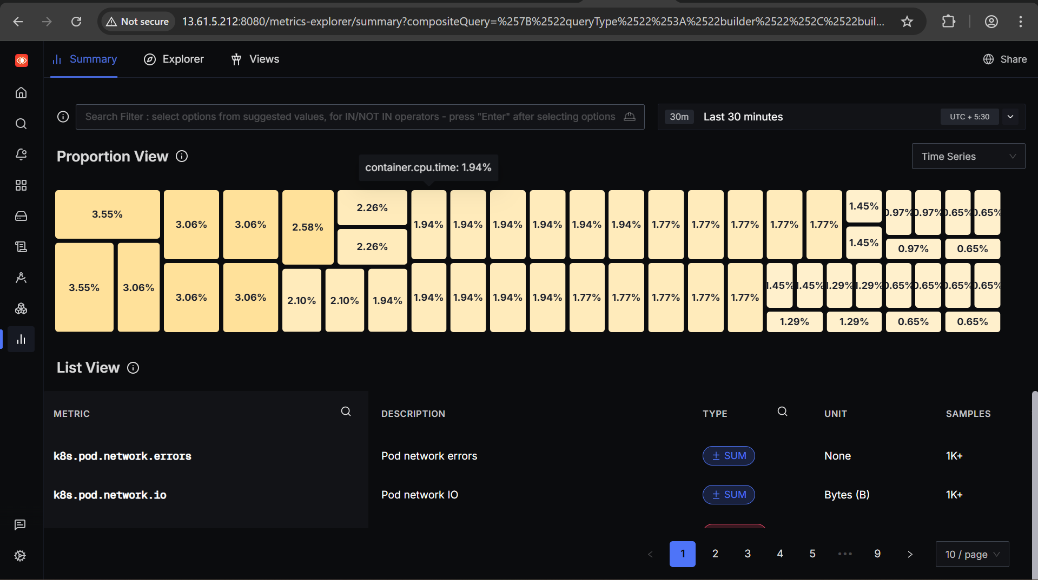

Infrastructure
Host
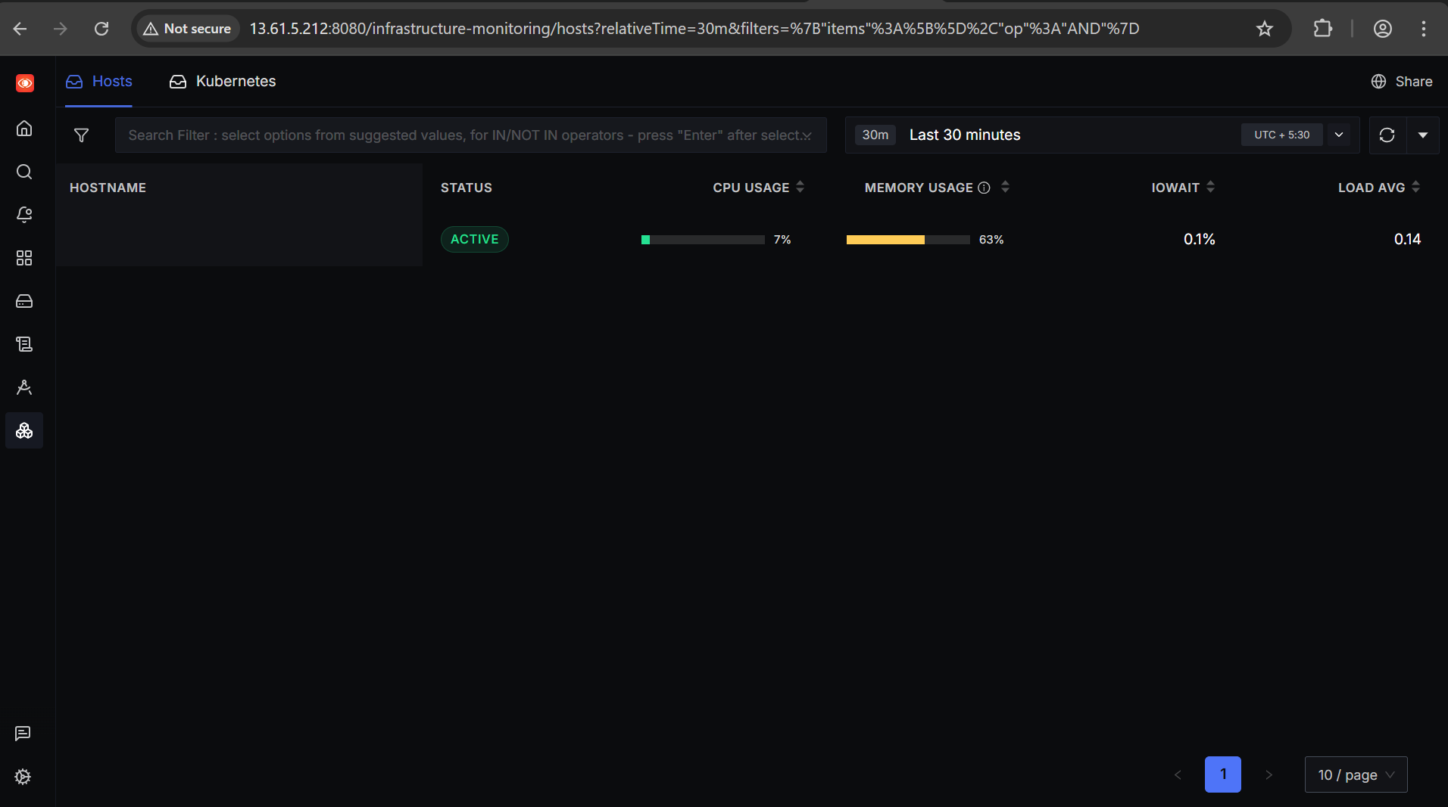
Kubernetes
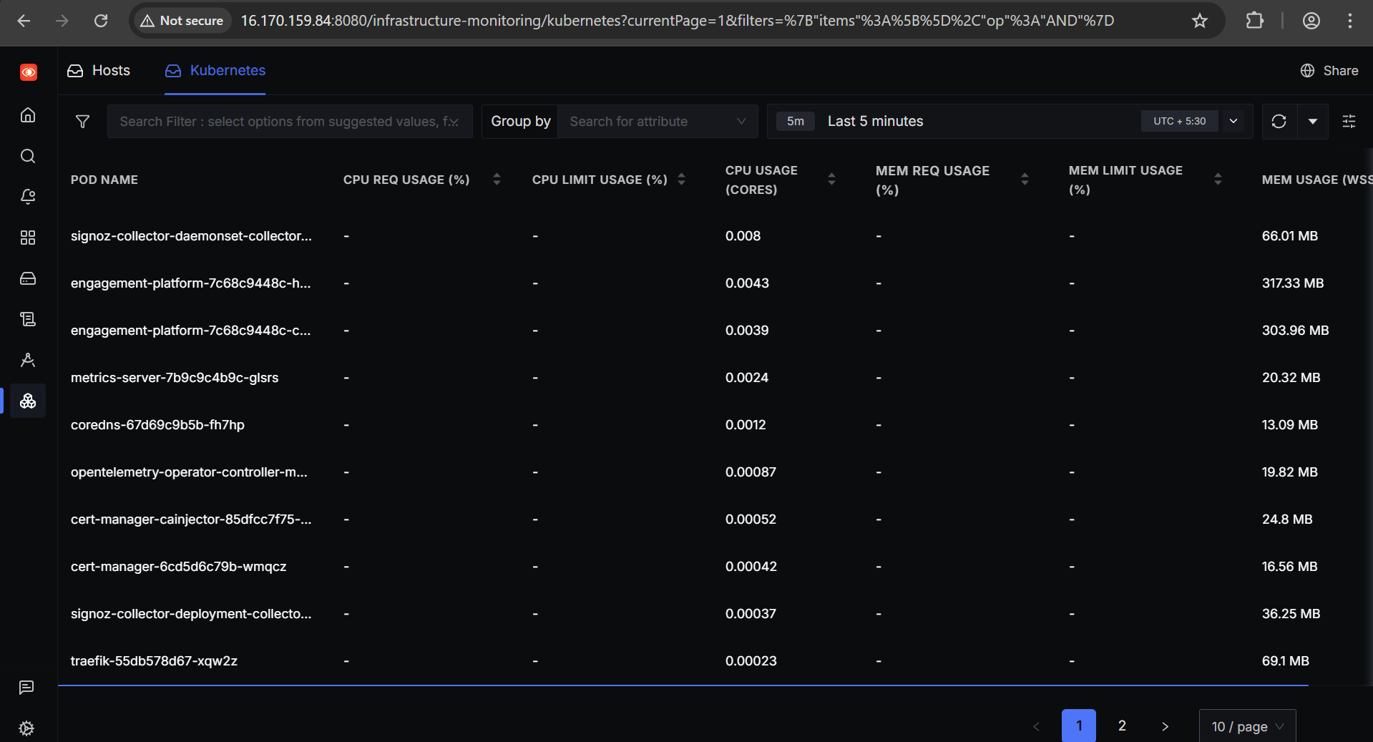

SPRINGBOOT APPLICATION DEPLOYEMENT
DO NOT FOLLOW THIS CHECK APPLICATION INSTRUMENTATION TOPIC IN BELOW PAGES
Pre-Requisite:
Docker must me installed.
K3s should be installed
engagement-platform.jar

STEP-1: Create Dockerfile
nano Dockerfile
# Use lightweight Java image
FROM eclipse-temurin:17-jdk-alpine

# Set working directory
WORKDIR /app

# Copy jar file
COPY engagement-platform.jar app.jar

# Expose application port (change if needed)
EXPOSE 8080

# Run the jar
CMD ["java","-jar","/app/app.jar"]

STEP-2: Build Docker Image
docker build -t <yourdockerhubusername>/engagement-platform:latest .
STEP-3: Push Image to Docker Hub
docker login
docker push <yourdockerhubusername>/engagement-platform:latest
STEP-4: Prepare Aiven MySQL Connection
Example:
Host: mysql-xxxxx.aivencloud.com
Port: 3306
Username: avnadmin
Password: xxxxxx
Database: engagementdb
STEP-5: Create Kubernetes Secret (For DB)
kubectl create secret generic mysql-secret \
--from-literal=SPRING_DATASOURCE_URL='jdbc:mysql://spring-boot-demo-pranavpp37-30bd.a.aivencloud.com:18510/defaultdb?ssl-mode=REQUIRED' \
--from-literal=SPRING_DATASOURCE_USERNAME='avnadmin' \
--from-literal=SPRING_DATASOURCE_PASSWORD='NEW_PASSWORD'
Verify secret exists:
kubectl get secrets
kubectl describe secret mysql-secret

STEP-6: Prepare Deployment YAML + Nodeport Service
engagement-platform.yaml
---
apiVersion: apps/v1
kind: Deployment
metadata:
name: engagement-platform
spec:
replicas: 2
selector:
matchLabels:
app: engagement-platform
template:
metadata:
labels:
app: engagement-platform
spec:
containers:
- name: engagement-platform
image: yourdockerhubusername/engagement-platform:v1.0.0
ports:
- containerPort: 8080
env:
- name: SPRING_DATASOURCE_URL
valueFrom:
secretKeyRef:
name: mysql-secret
key: SPRING_DATASOURCE_URL
- name: SPRING_DATASOURCE_USERNAME
valueFrom:
secretKeyRef:
name: mysql-secret
key: SPRING_DATASOURCE_USERNAME
- name: SPRING_DATASOURCE_PASSWORD
valueFrom:
secretKeyRef:
name: mysql-secret
key: SPRING_DATASOURCE_PASSWORD
resources:
requests:
memory: "512Mi"
cpu: "250m"
limits:
memory: "1Gi"
cpu: "500m"
livenessProbe:
httpGet:
path: /actuator/health
port: 8080
initialDelaySeconds: 30
periodSeconds: 10
readinessProbe:
httpGet:
path: /actuator/health
port: 8080
initialDelaySeconds: 15
periodSeconds: 5
---
apiVersion: v1
kind: Service
metadata:
name: engagement-platform-service
spec:
type: NodePort
sessionAffinity: ClientIP
selector:
app: engagement-platform
ports:
- protocol: TCP
port: 80 # External port
targetPort: 8080 # Container port
nodePort: 30080 # NodePort (choose between 30000-32767)

IMPORTANT NOTE:
Login issue in Kubernetes
- When using multiple replicas, clicking the dashboard after login redirects to /login.
- Reason: Spring Security stores sessions in-memory per pod. Kubernetes Service load balances randomly → session lost if request goes to another pod.
Solution applied
- Added sessionAffinity: ClientIP to the NodePort service.
- Why it works: Sticky sessions send all requests from the same client IP to the same pod, preserving the in-memory session.
- Quick fix for multi-replica setup without changing the app.

kubectl apply -f engagement-platform.yaml
kubectl get pods
kubectl get deployment
kubectl get svc

Access Your App:
In VM
curl http://<EC2_PUBLIC_IP>:30080/login
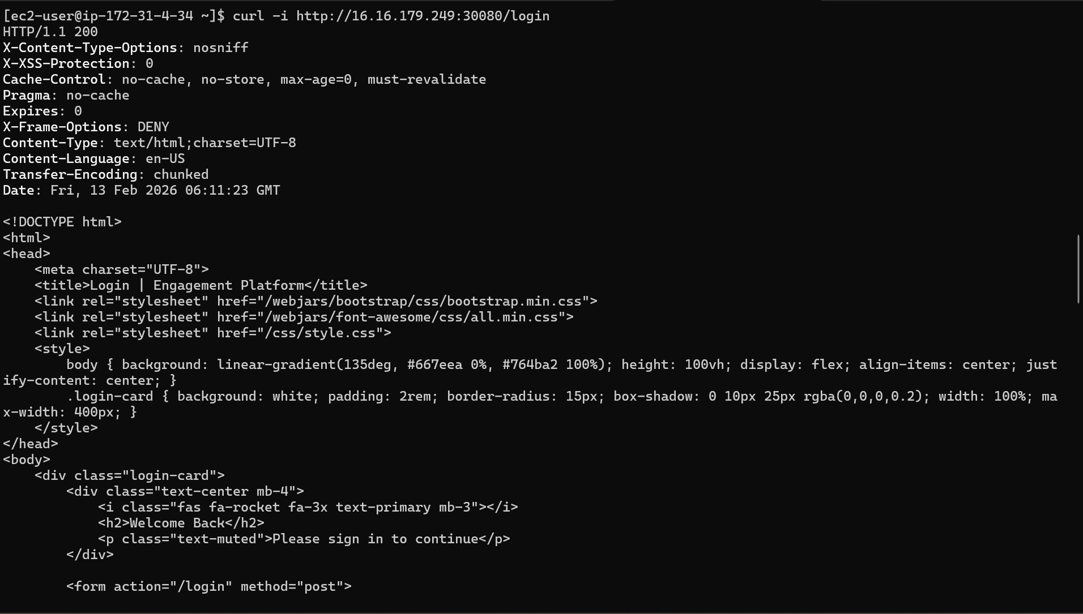
In browser
http://<EC2_PUBLIC_IP>:30080/login

APPLICATION JAVA INSTRUMENTATION
Step-1: Install OpenTelemetry Java Instrumentation Agent
curl -LO https://github.com/open-telemetry/opentelemetry-java-instrumentation/releases/download/v2.25.0/opentelemetry-javaagent.jar
Step-2: Dockerfile
# Eclipse Temurin base
FROM eclipse-temurin:17-jdk

WORKDIR /app

# Copy your app jar
COPY engagement-platform.jar app.jar

# Copy OTEL Java agent jar
COPY opentelemetry-javaagent.jar /otel-javaagent/opentelemetry-javaagent.jar

# Expose application port
EXPOSE 8080

# Default command just runs the jar
ENTRYPOINT ["java", "-javaagent:/otel-javaagent/opentelemetry-javaagent.jar", "-jar", "app.jar"]

STEP-3: Build and Push
docker build -t pranavpp37/engagement-javaagent:1.0 .
docker push pranavpp37/engagement-javaagent:1.0

STEP-4: Deployment Yaml
engagement-platform.yaml
---
apiVersion: apps/v1
kind: Deployment
metadata:
name: engagement-platform
namespace: default
spec:
replicas: 2
selector:
matchLabels:
app: engagement-platform
template:
metadata:
labels:
app: engagement-platform
spec:
containers:
- name: engagement-platform
image: pranavpp37/engagement-platform-new:1.0
ports:
- containerPort: 8080
env:
# Database Configuration
- name: SPRING_DATASOURCE_URL
valueFrom:
secretKeyRef:
name: mysql-secret
key: SPRING_DATASOURCE_URL
- name: SPRING_DATASOURCE_USERNAME
valueFrom:
secretKeyRef:
name: mysql-secret
key: SPRING_DATASOURCE_USERNAME
- name: SPRING_DATASOURCE_PASSWORD
valueFrom:
secretKeyRef:
name: mysql-secret
key: SPRING_DATASOURCE_PASSWORD

# OpenTelemetry Configuration
- name: K8S_NODE_IP
valueFrom:
fieldRef:
fieldPath: status.hostIP

- name: OTEL_EXPORTER_OTLP_PROTOCOL
value: "grpc"

- name: OTEL_EXPORTER_OTLP_ENDPOINT
value: "http://$(K8S_NODE_IP):4317"

- name: OTEL_EXPORTER_OTLP_INSECURE
value: "true"

- name: OTEL_SERVICE_NAME
value: "engagement-platform"

- name: OTEL_RESOURCE_ATTRIBUTES
value: "service.name=engagement-platform,service.namespace=default,deployment.environment=production"

- name: OTEL_TRACES_EXPORTER
value: "otlp"

- name: OTEL_METRICS_EXPORTER
value: "otlp"

- name: OTEL_LOGS_EXPORTER
value: "otlp"

- name: OTEL_INSTRUMENTATION_COMMON_DEFAULT_ENABLED
value: "true"

- name: OTEL_INSTRUMENTATION_JDBC_ENABLED
value: "true"

- name: OTEL_INSTRUMENTATION_SPRING_WEBMVC_ENABLED
value: "true"

- name: OTEL_INSTRUMENTATION_HIBERNATE_ENABLED
value: "true"

resources:
requests:
memory: "512Mi"
cpu: "250m"
limits:
memory: "1Gi"
cpu: "500m"

livenessProbe:
httpGet:
path: /actuator/health
port: 8080
initialDelaySeconds: 60
periodSeconds: 10
timeoutSeconds: 5
failureThreshold: 3

readinessProbe:
httpGet:
path: /actuator/health
port: 8080
initialDelaySeconds: 45
periodSeconds: 5
timeoutSeconds: 3
failureThreshold: 3

---
apiVersion: v1
kind: Service
metadata:
name: engagement-platform-service
namespace: default
spec:
type: NodePort
sessionAffinity: ClientIP # Added
selector:
app: engagement-platform
ports:
- protocol: TCP
port: 80
targetPort: 8080
nodePort: 30080

STEP-5: Add Kubernetes Secrets
sudo kubectl create secret generic mysql-secret \ --from-literal=SPRING_DATASOURCE_URL='jdbc:mysql://your-mysql-host:port/database?ssl-mode=REQUIRED' \ --from-literal=SPRING_DATASOURCE_USERNAME='your-username' \ --from-literal=SPRING_DATASOURCE_PASSWORD='your-password'

sudo kubectl create secret generic mysql-secret \
--from-literal=SPRING_DATASOURCE_URL='jdbc:mysql://spring-boot-demo-pranavpp37-30bd.a.aivencloud.com:18510/defaultdb?ssl-mode=REQUIRED' \
--from-literal=SPRING_DATASOURCE_USERNAME='avnadmin' \
--from-literal=SPRING_DATASOURCE_PASSWORD='<Your Password>'

STEP-6: Deploy application
sudo kubectl apply -f engagement-platform.yaml

STEP-7: Verify everything
sudo kubectl get pods -A
sudo netstat -tlnp | grep 4317
sudo kubectl logs deployment/engagement-platform -f
STEP-8: Access in Browser
http://<EC2_PUBLIC_IP>:30080/login

STEP-9: Check in Signoz UI
http://<SIGNOZ-UI-IP>:8080/

Traces

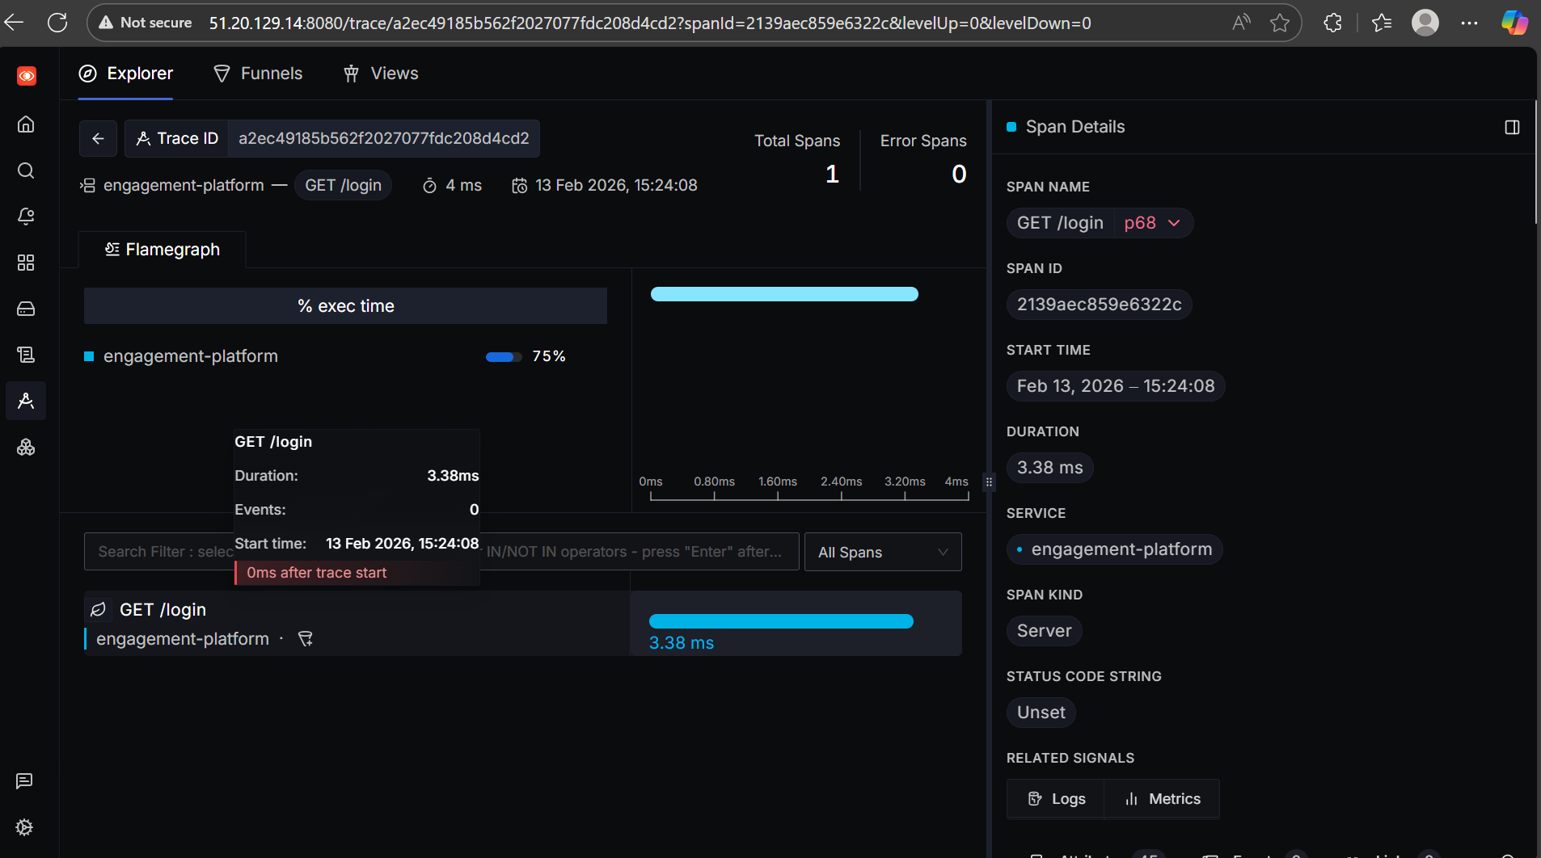

Logs
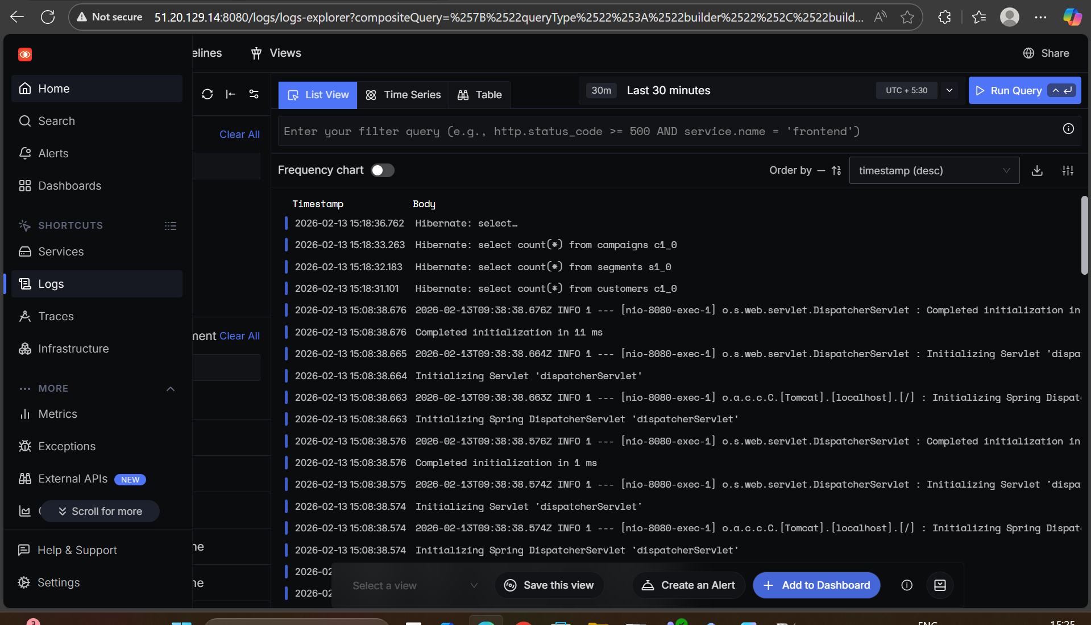

Metrics

Services

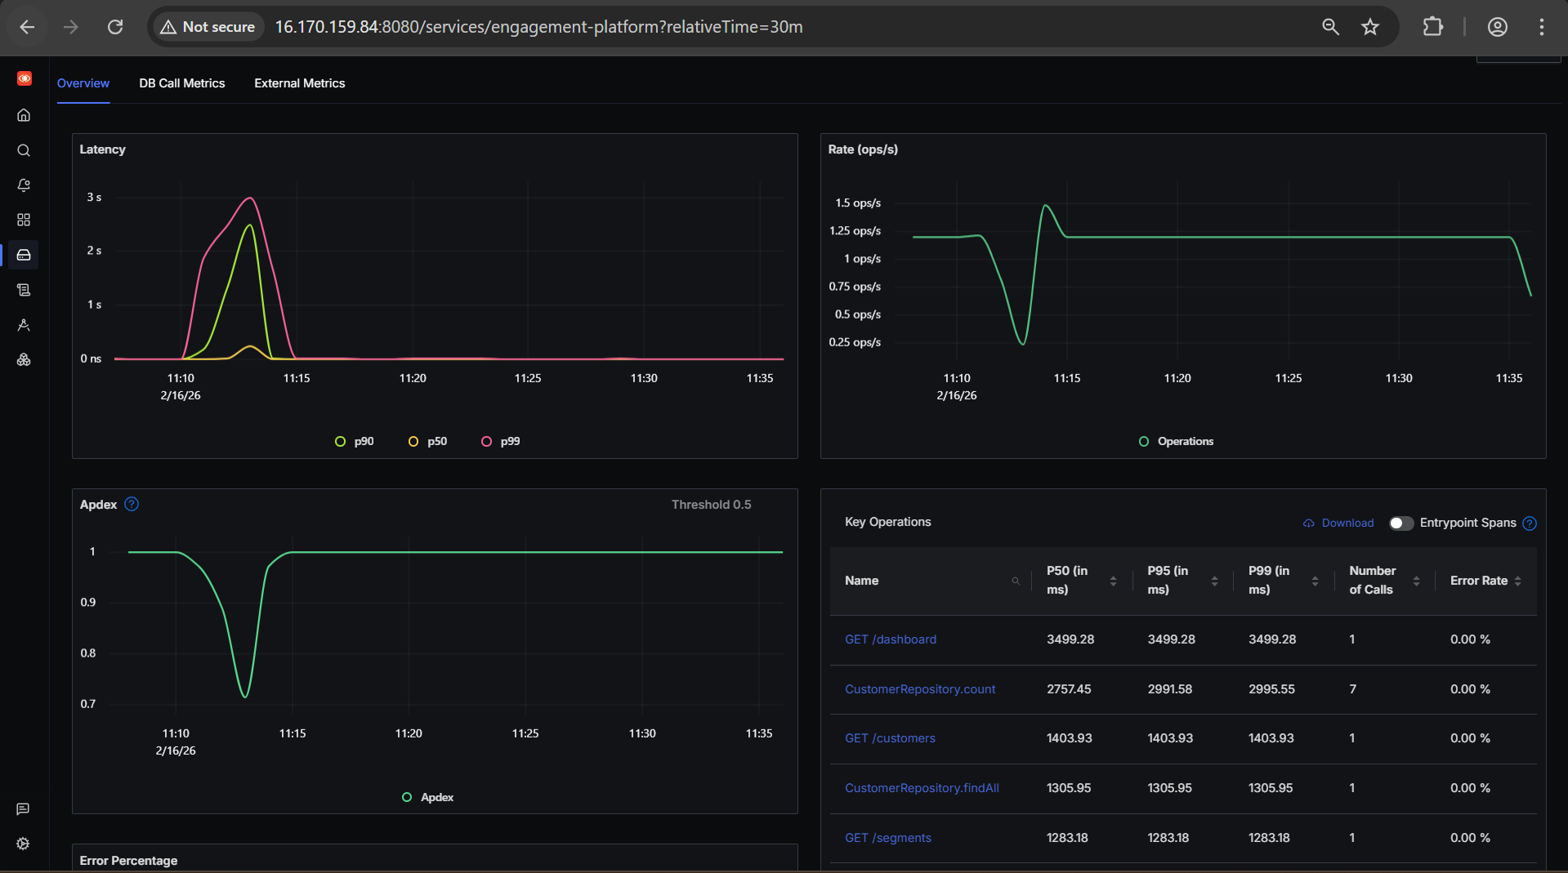
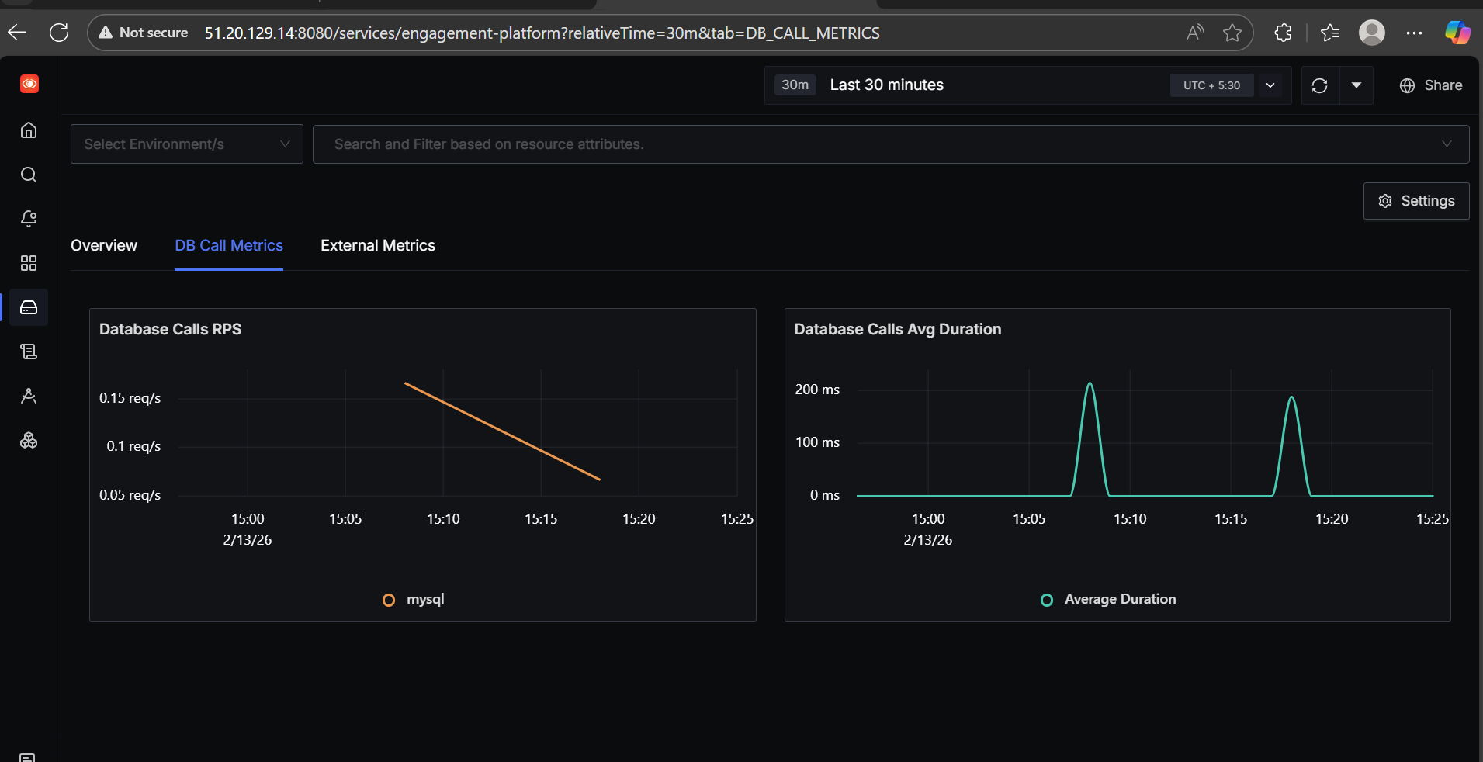
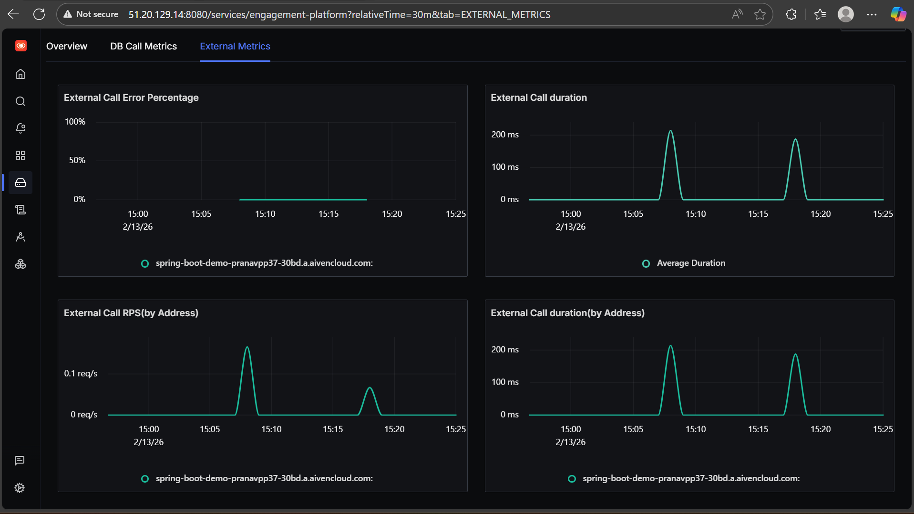

ANOTHER METHOD TO INSTRUMENT JAVA APPLICATION USING OPERATOR
STEP-1:Operator is already installed
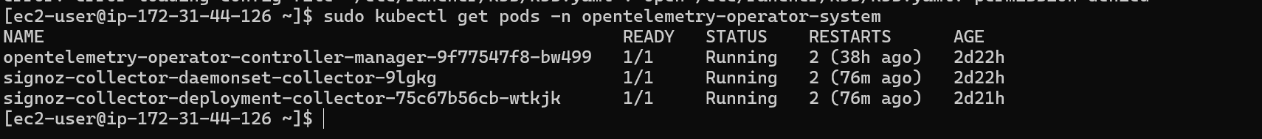
STEP-2: Create Instrumentation Resource
sudo vi instrumentation.yaml
apiVersion: opentelemetry.io/v1alpha1
kind: Instrumentation
metadata:
name: java-instrumentation
namespace: default
spec:
exporter:
endpoint: http://signoz-collector:4317
propagators:
- tracecontext
- baggage
sampler:
type: parentbased_traceidratio
argument: "1"

sudo kubectl apply -f instrumentation.yaml

STEP-3: Remove agent and have clean Dockerfile
FROM eclipse-temurin:17-jdk

WORKDIR /app

COPY demo-0.0.1-SNAPSHOT.jar app.jar

EXPOSE 8080

ENTRYPOINT ["java", "-jar", "app.jar"]

STEP-4: Add Annotation To Deployment
template:
metadata:
annotations:
instrumentation.opentelemetry.io/inject-java: "true"
labels:
app: engagement-platform

